Objective 1: Set up the primary version of the web application in N.Virginia. Tasks:

Acquire an Elastic IP (EIP).

Attach the EIP to an EC2 instance in N.Virginia.

Make sure to verify the EC2 instance in N.Virginia has a reliable public address.

Objective 2: Establish a backup in Oregon to ensure high availability. - Tasks:

Create a backup (AMI) of this EC2 instance in a different region (Oregon).

Objective 3: Set up an Amazon Elastic File System (EFS) for shared data storage. - Tasks:

Create an Amazon EFS in N. Virginia.

Create a private instance in Oregon using the above created AMI and install required dependencies to mount EFS, once dependencies are installed revoke the internet access to the instance.

Implement access controls to allow both N. Virginia and Oregon EC2 instances to access the EFS.

ANS :-

For this task first we have to create an Elastic IP

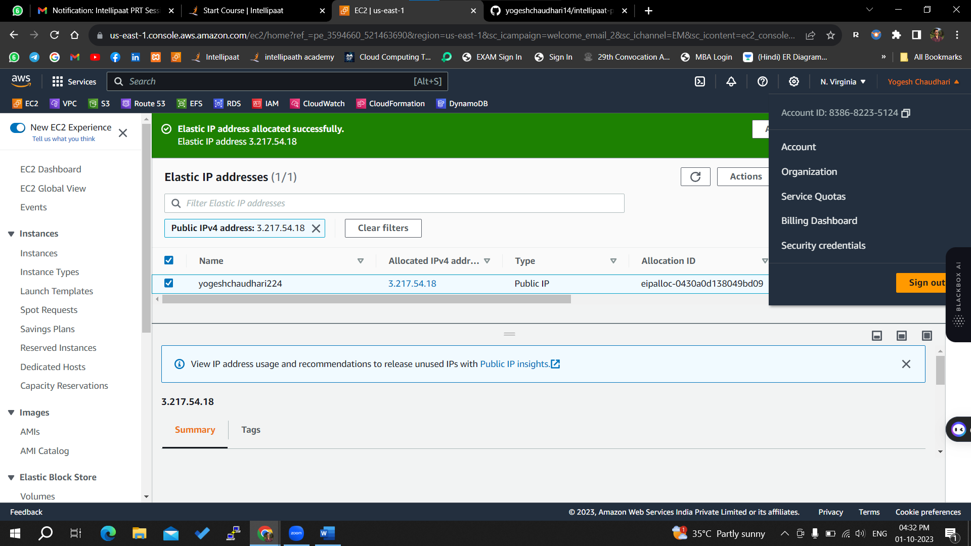

Above we have successfully created an Elastic IP

Now we have to attach this ip to our instance for that we will go to instance and create an new ubuntu instance

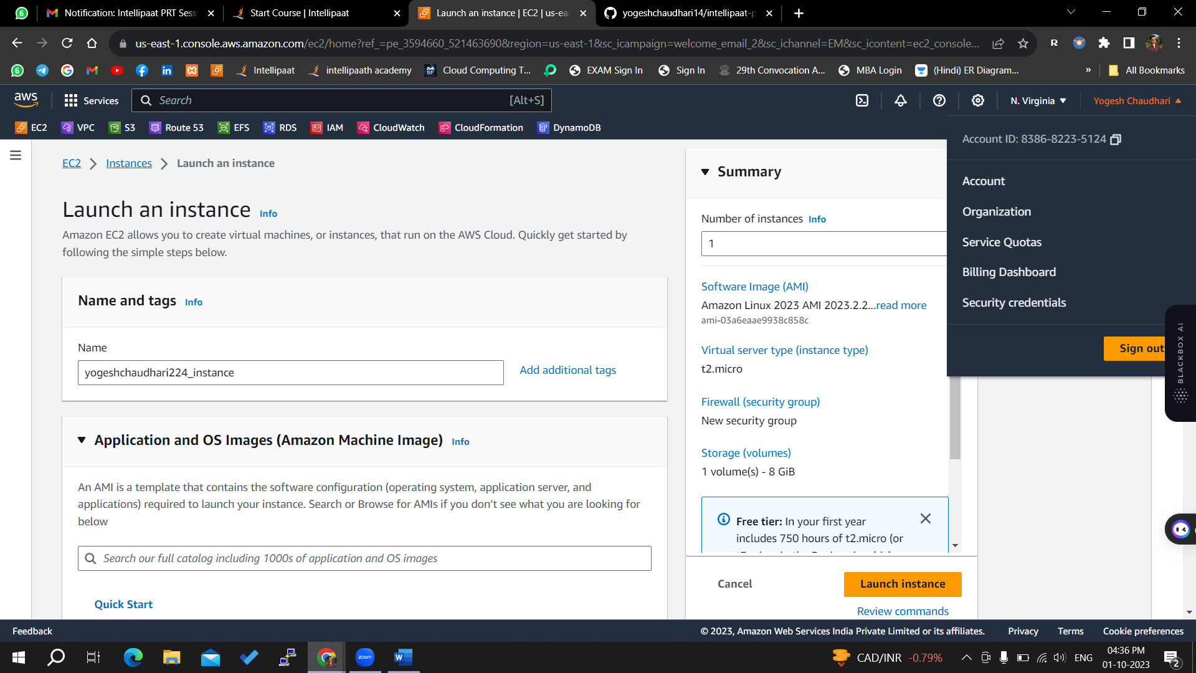

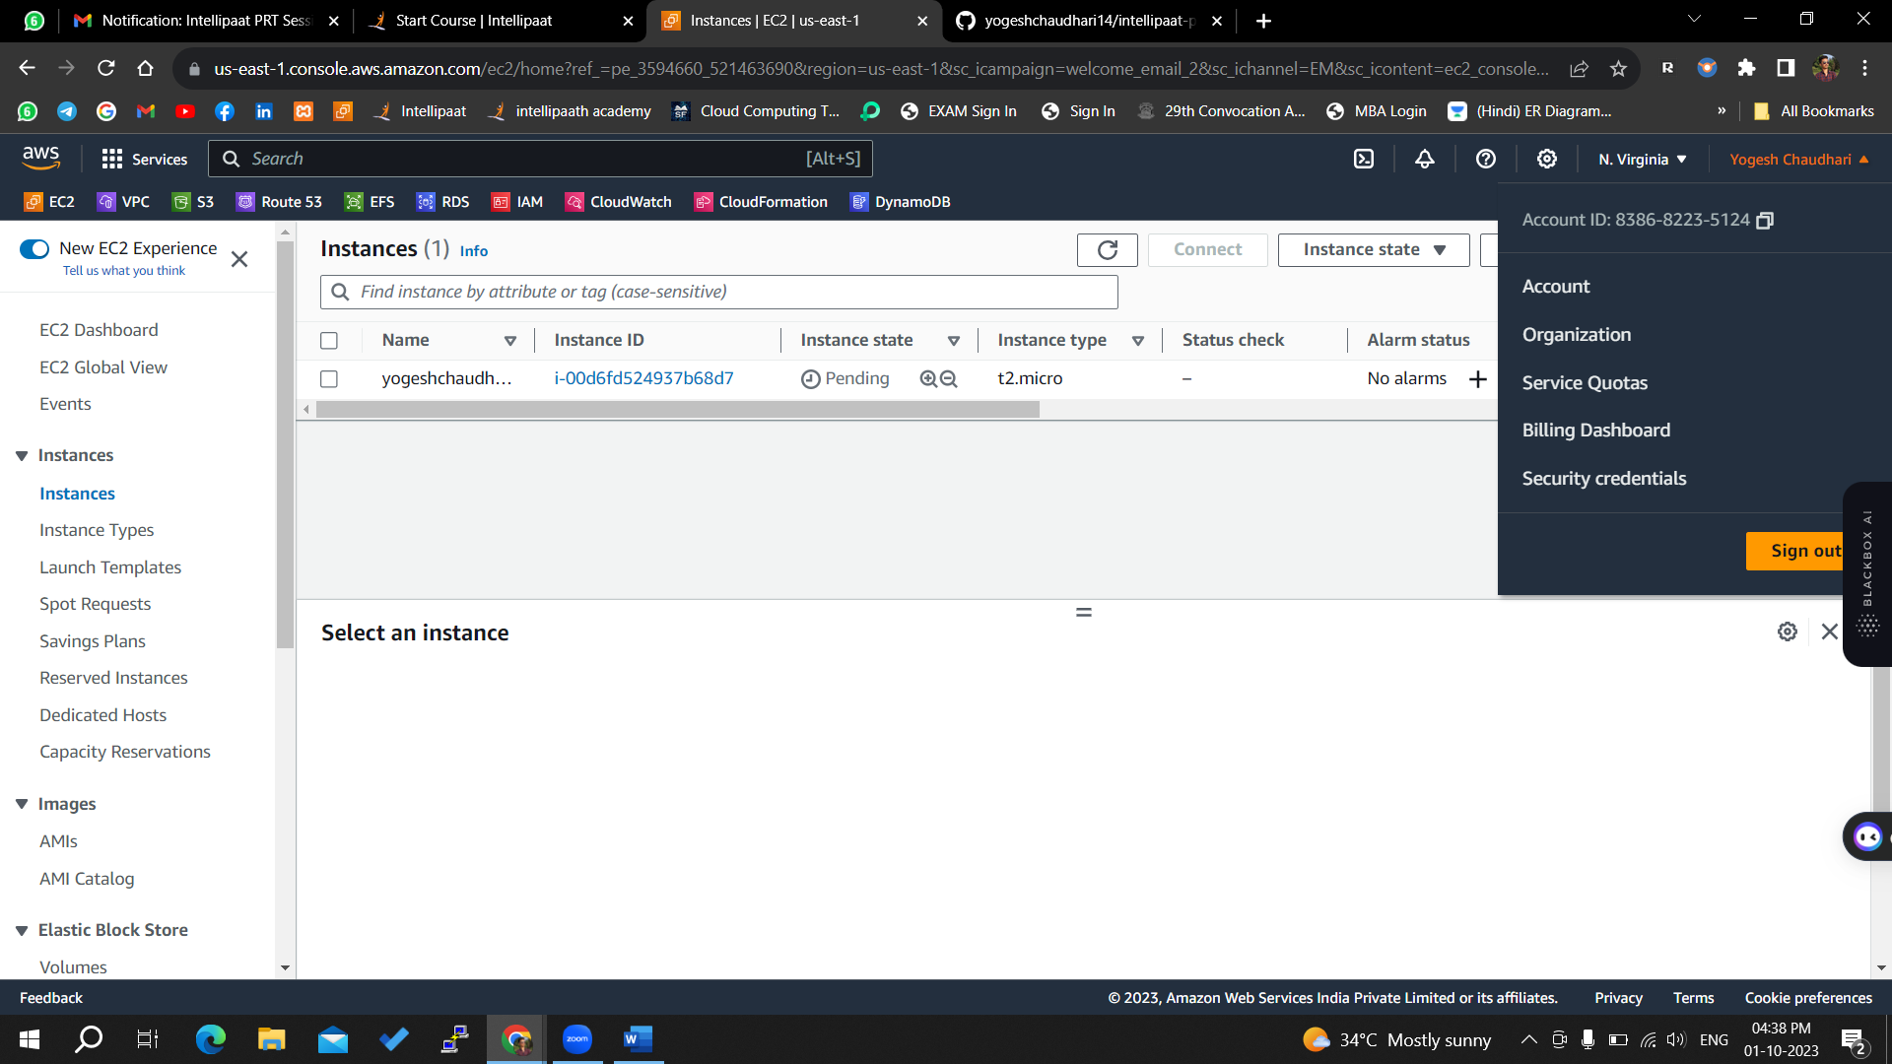

On above we have successfully created an instance now we will attach Elastic IP that we have created

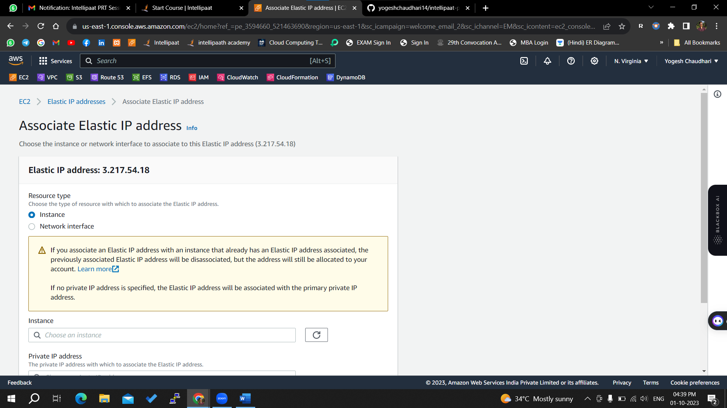

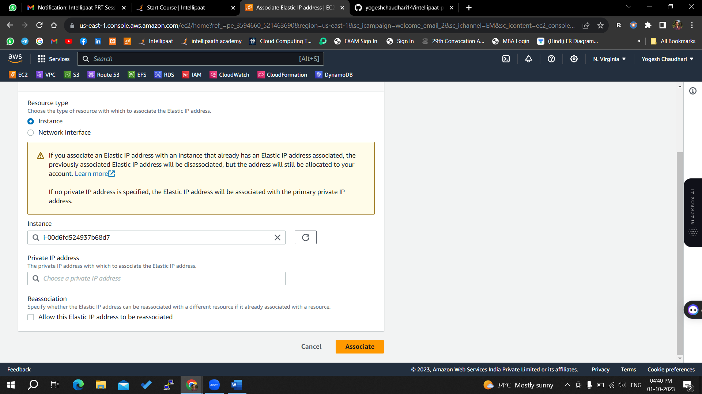

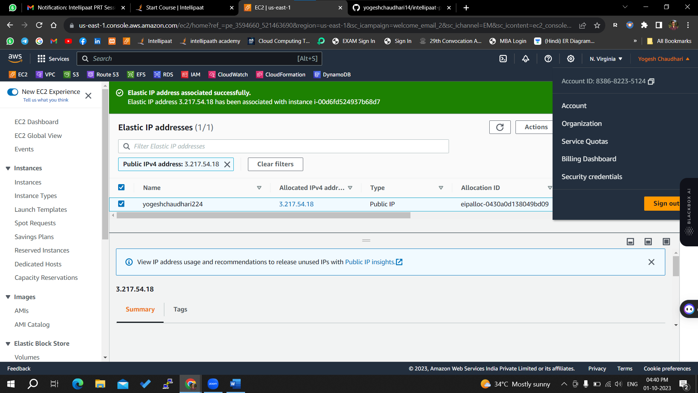

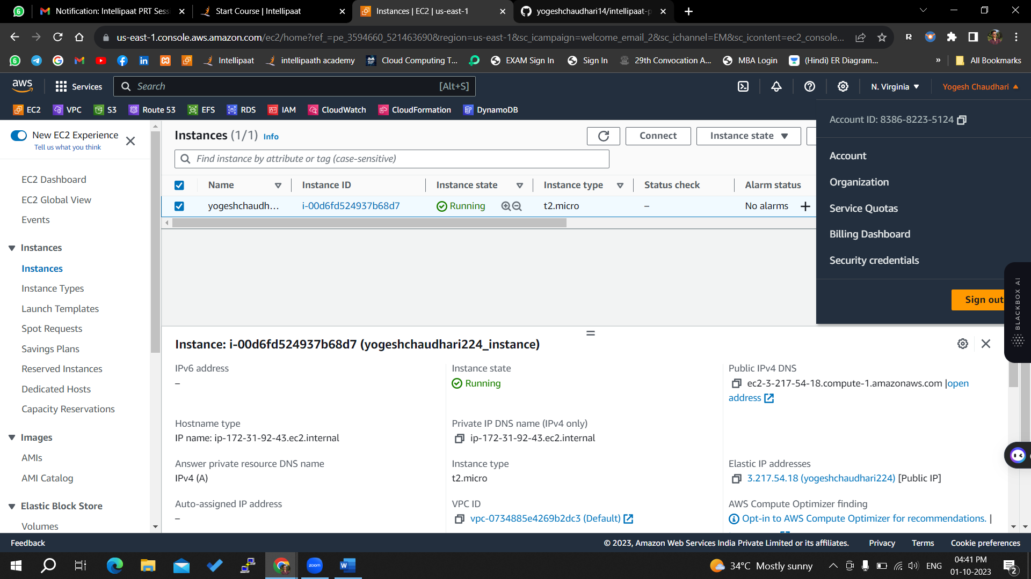



Above we attach elastic IP

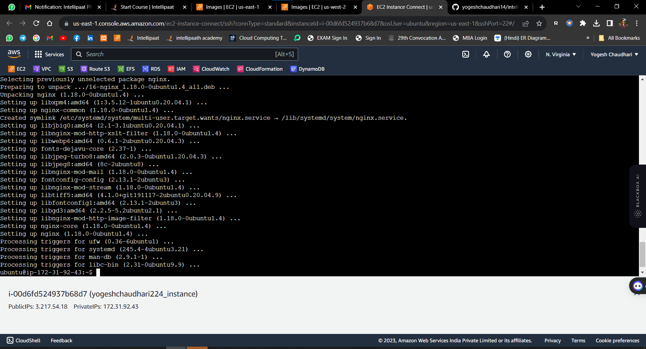

It is connected using ssh

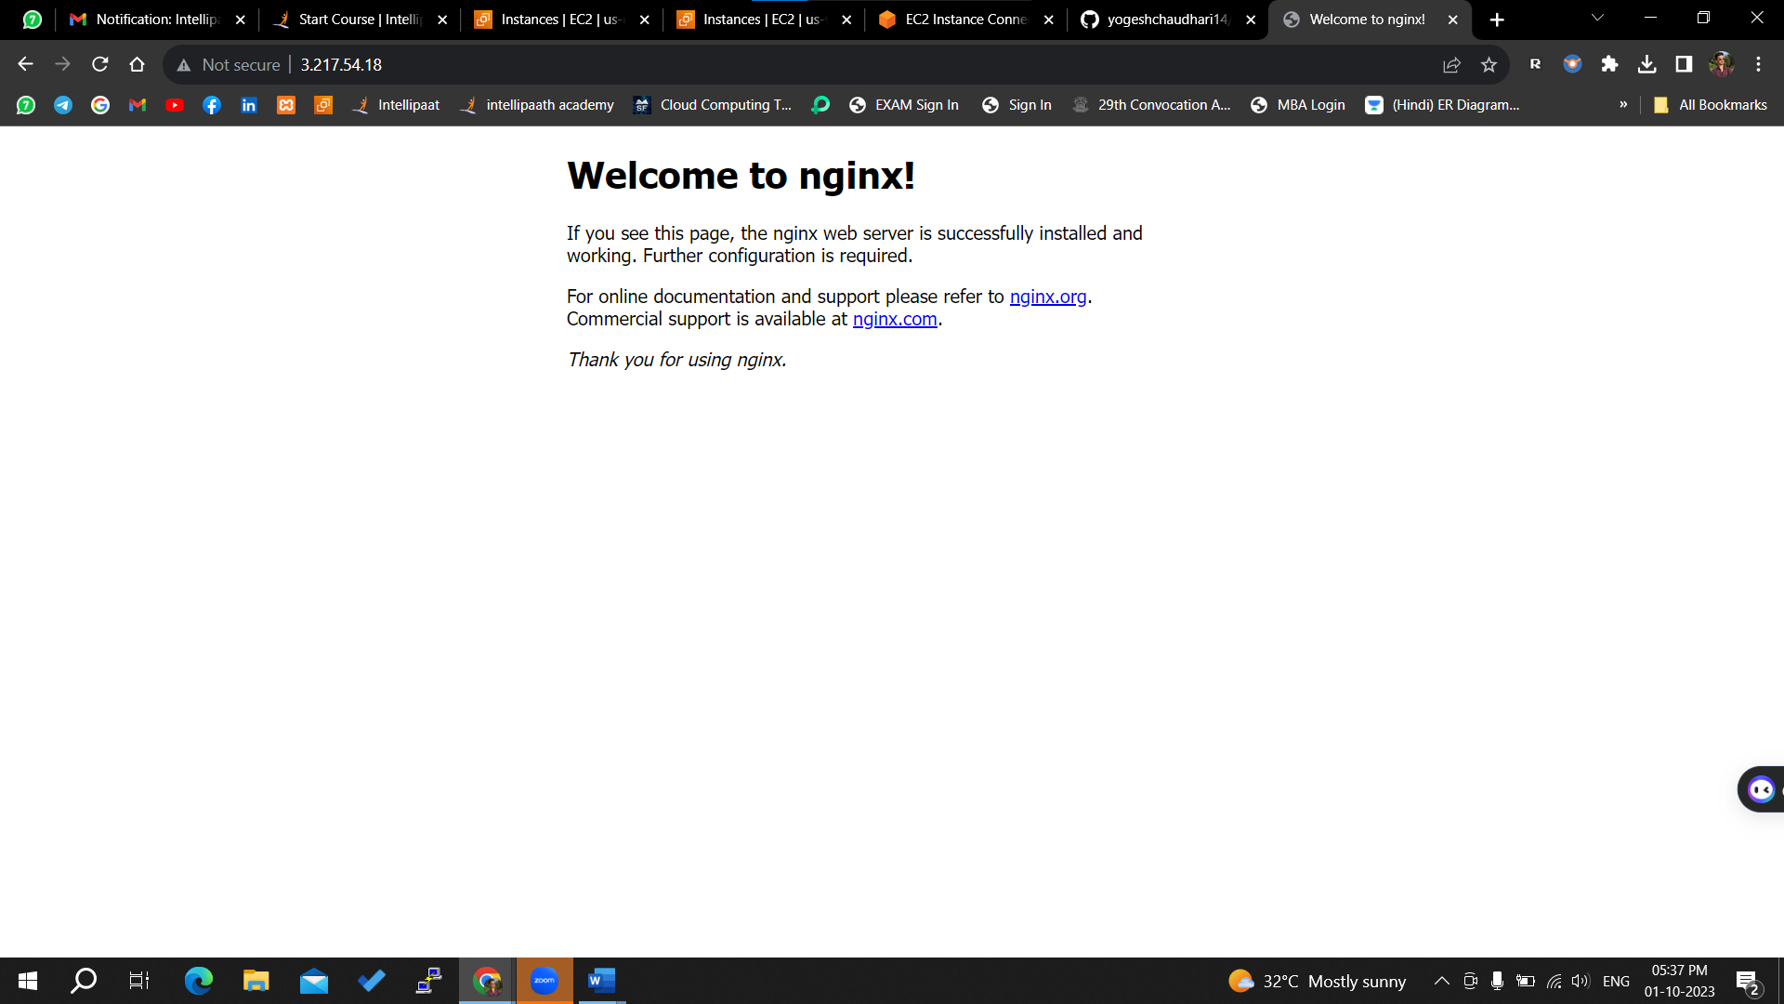

Now we will create a backup of this AMI

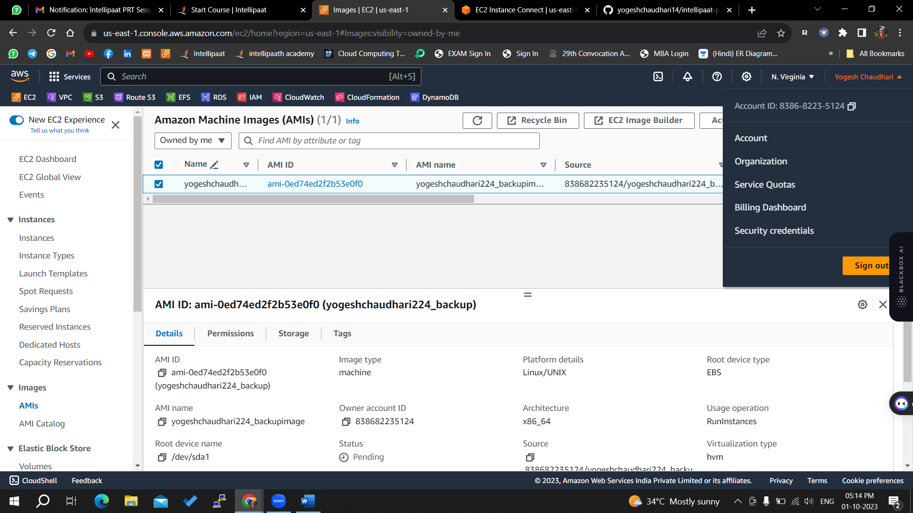

We created an AMI of our current instance

## Objective 2: Establish a backup in Oregon to ensure high availability. - Tasks:

## Create a backup (AMI) of this EC2 instance in a different region (Oregon).

Now we will copy this AMI in oregaon region

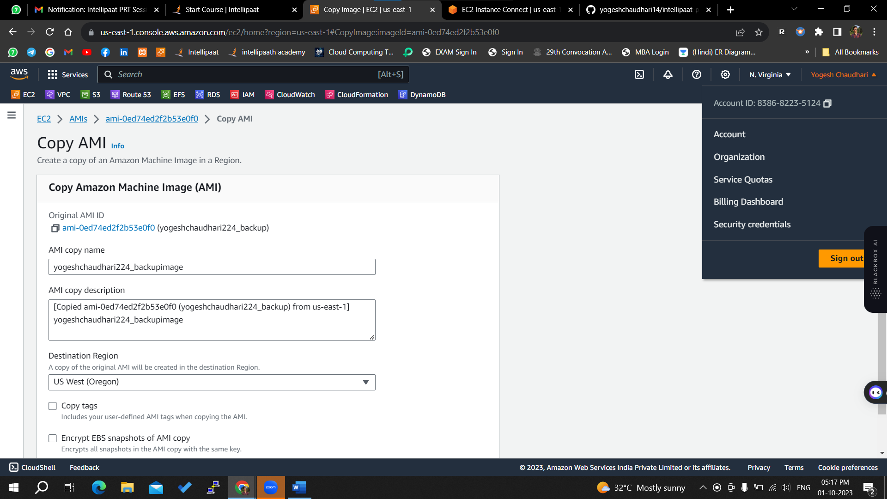

No we will go to Oregon region and check this AMI is available or not

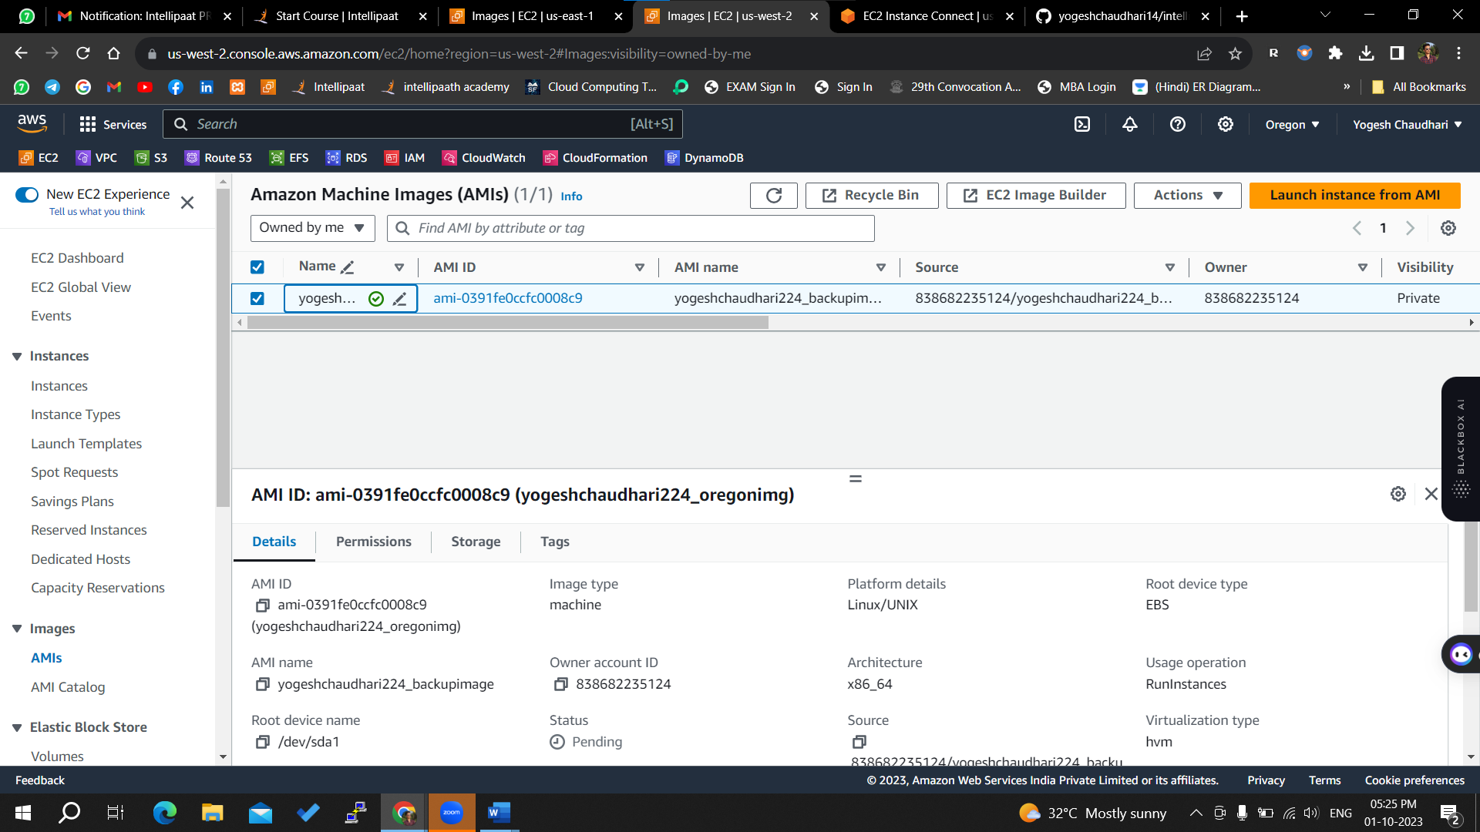

This AMI is Availabe in Oregon region

## Objective 3: Set up an Amazon Elastic File System (EFS) for shared data storage. - Tasks:

## Create an Amazon EFS in N. Virginia.

## Create a private instance in Oregon using the above created AMI and install required dependencies to mount EFS, once dependencies are installed revoke the internet access to the instance.

## Implement access controls to allow both N. Virginia and Oregon EC2 instances to access the EFS.

Now we will create an instance from this AMI

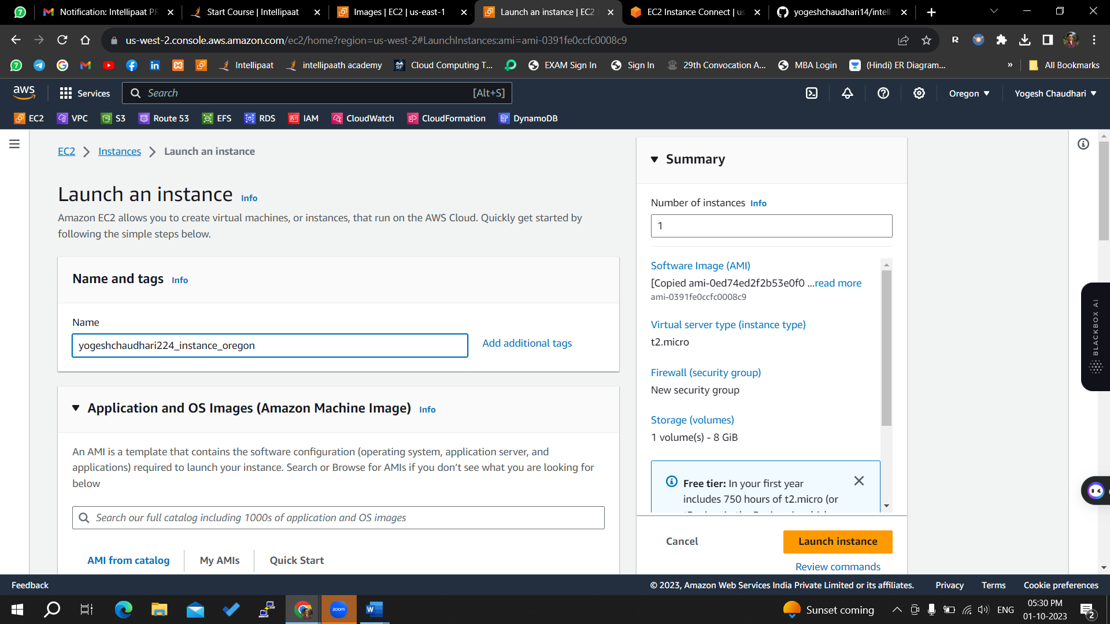

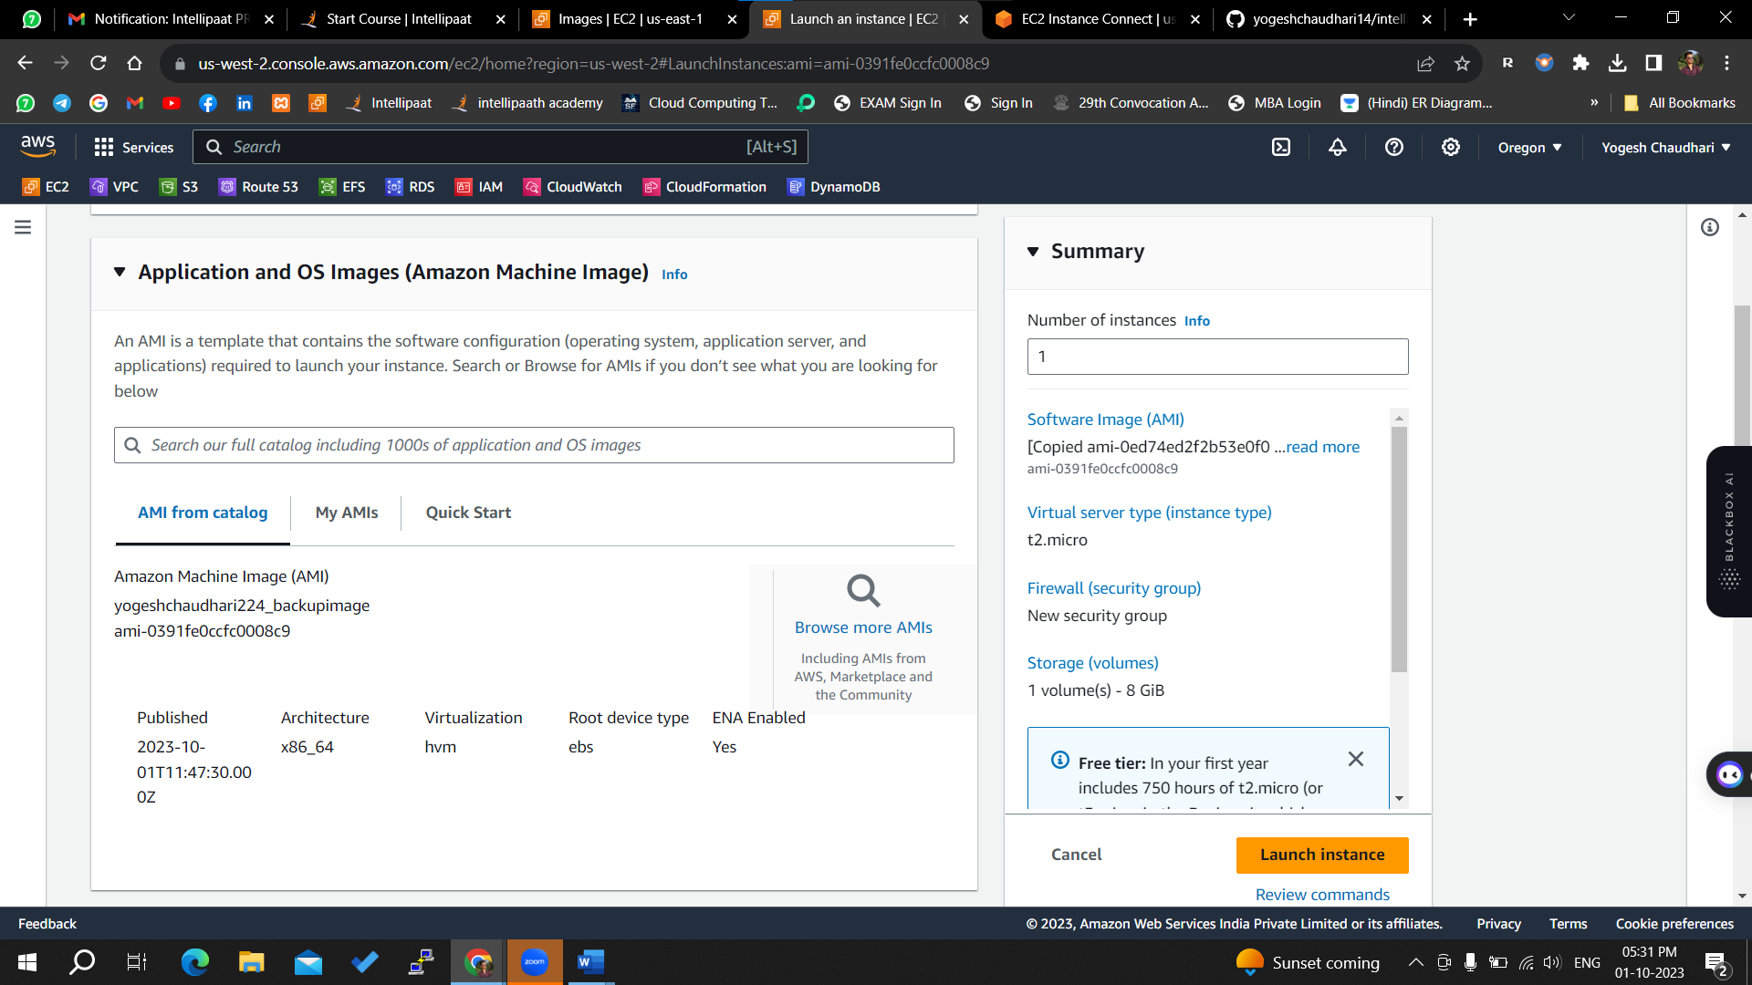

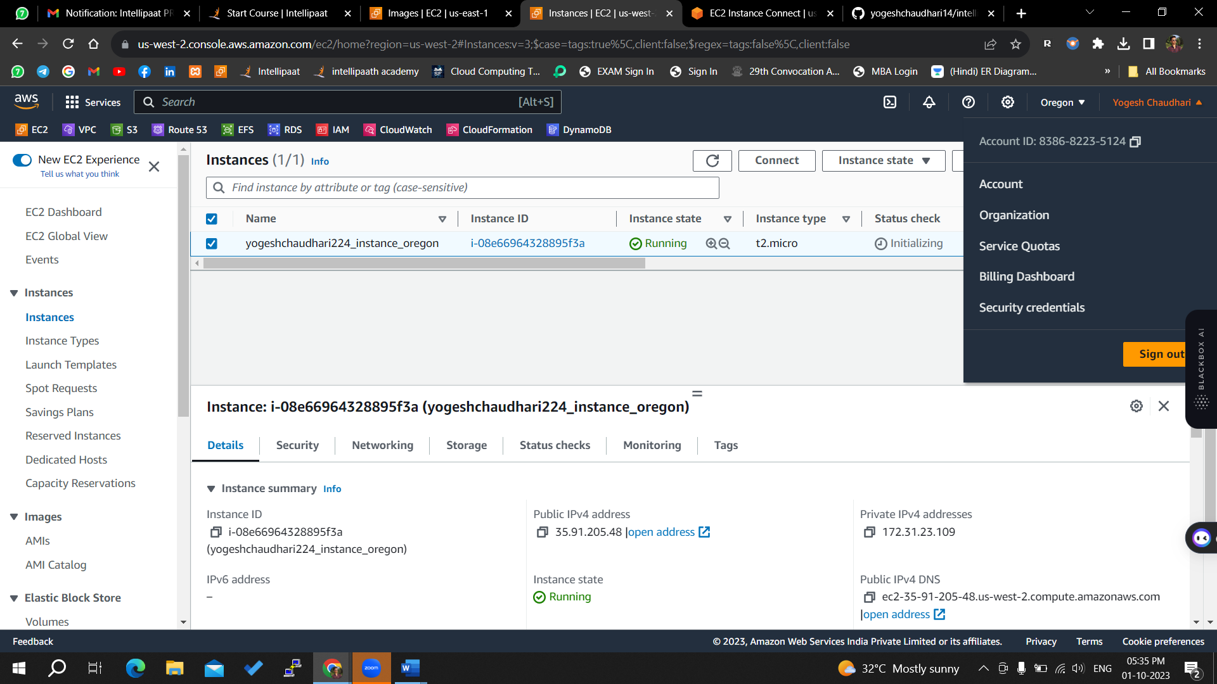

Successfully created an instance from AMI

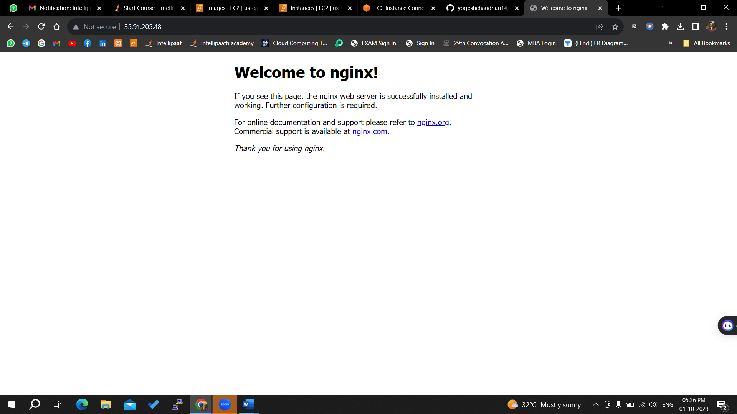

Also it is working

Now we will connet this via ssh

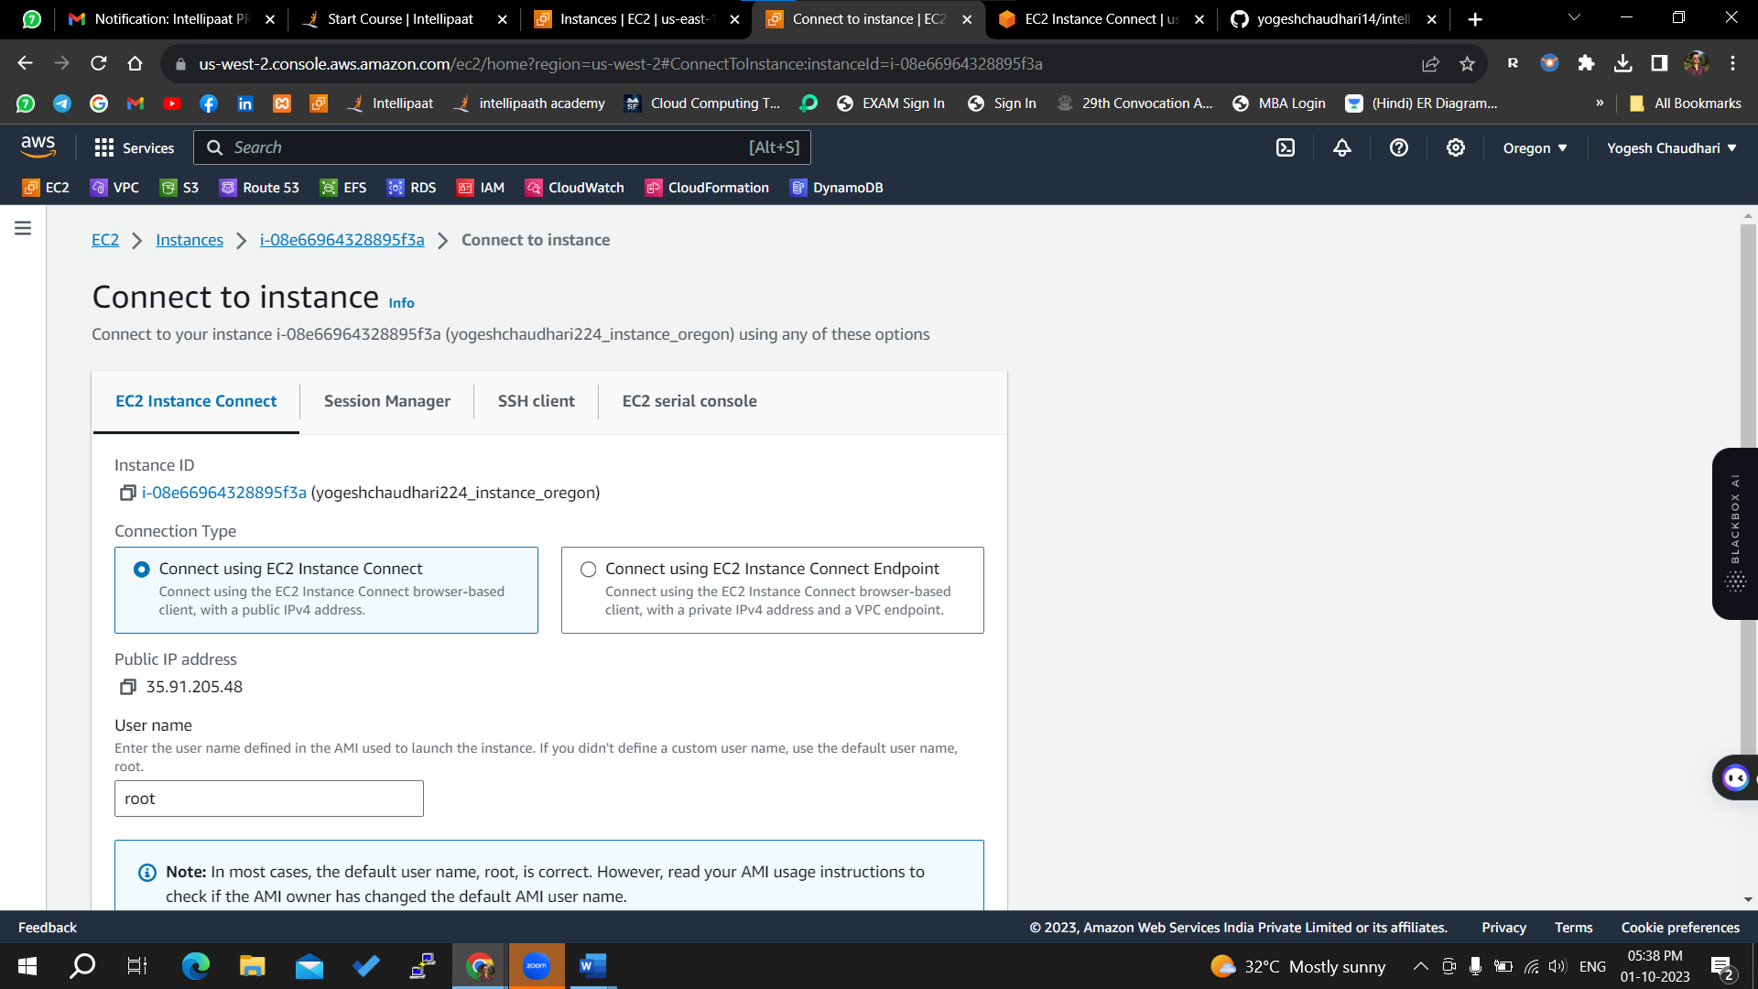

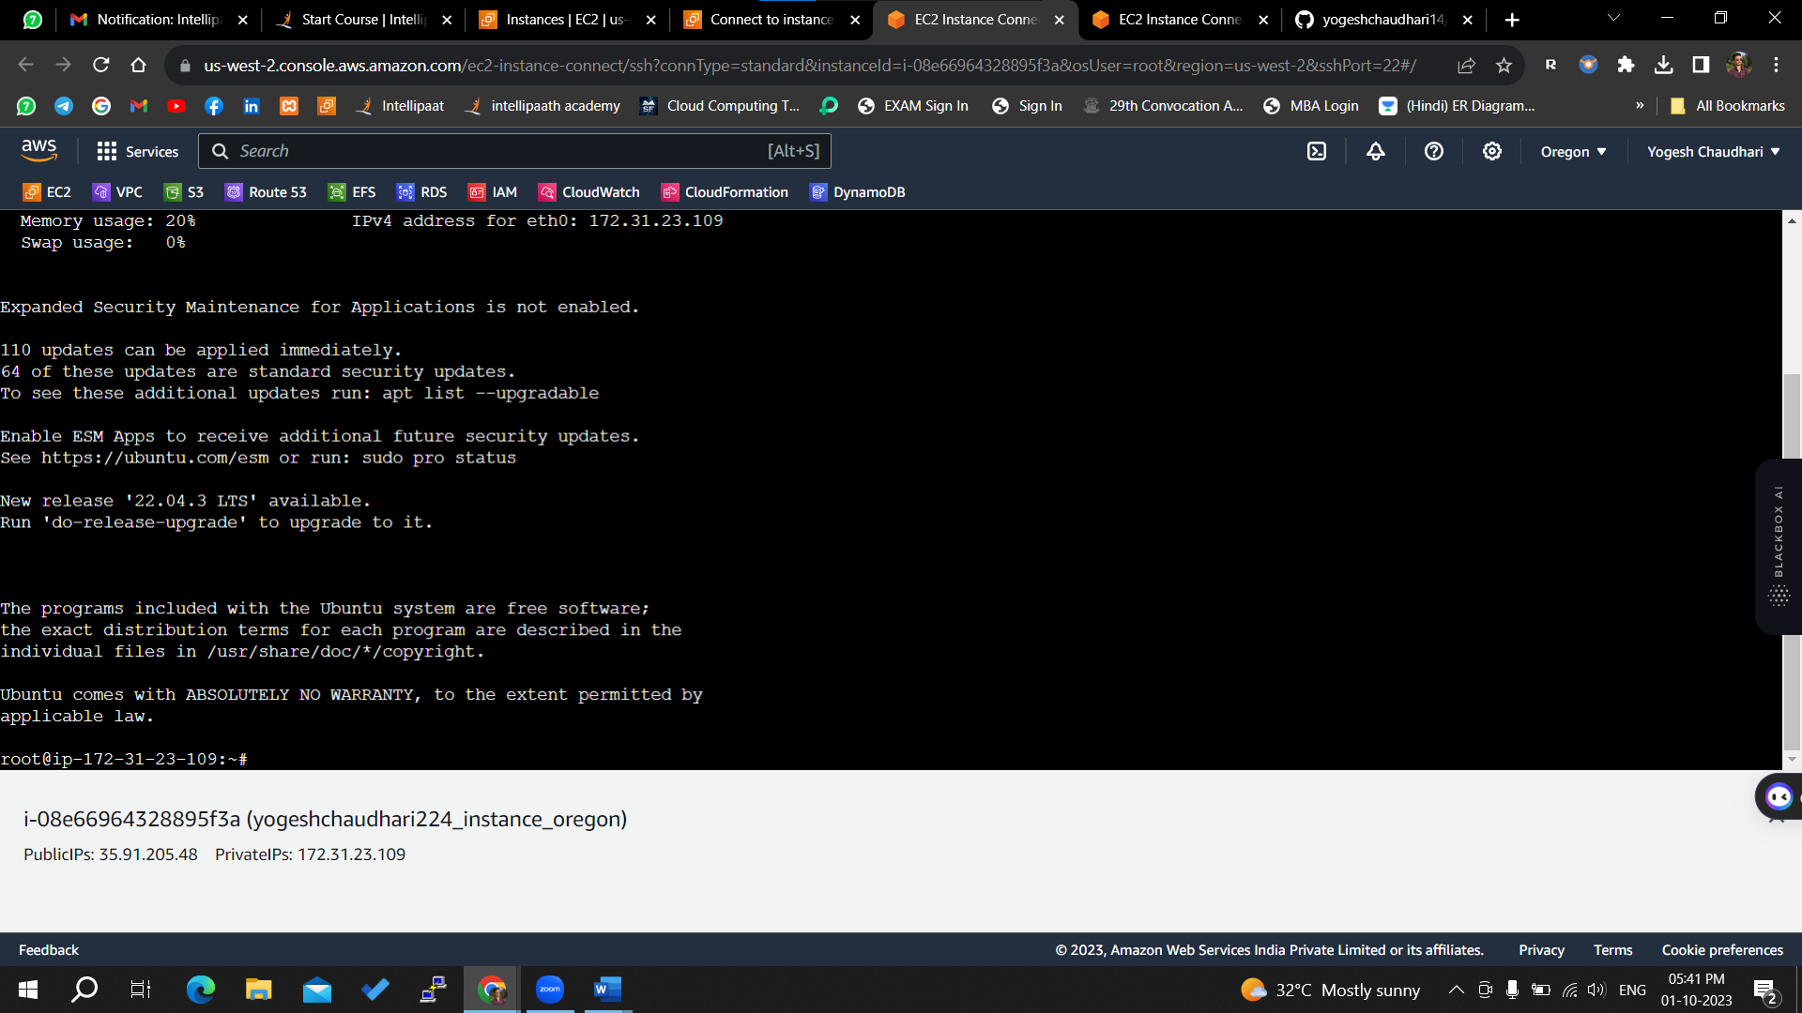

Now we will create an EFS

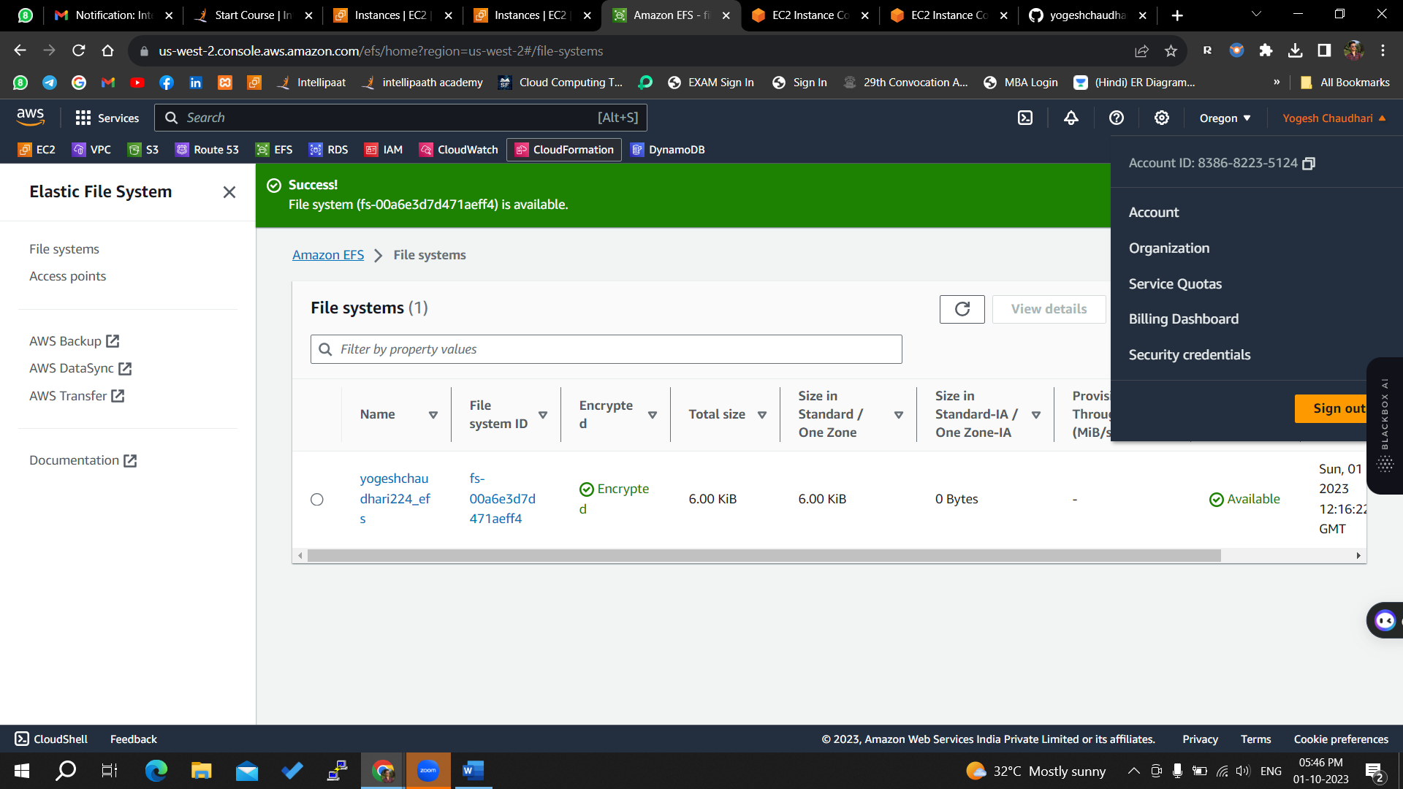

Now we will be install dependency for EFS

